|  |  |  |
| --- | --- | --- |
|  | AFSA - IRS **NEWSLETTER**  *A Publication of the* ***A****ssociation of* ***F****ormer* ***S****pecial* ***A****gents of the IRS* |  |
| Vol. XXXV No. 1 |  | Spring, 2024 |

**2024 AFSA Convention**

**The Embassy Suites Hotel Louisville Downtown**

**Louisville, Kentucky**

**October 6-9, 2024**

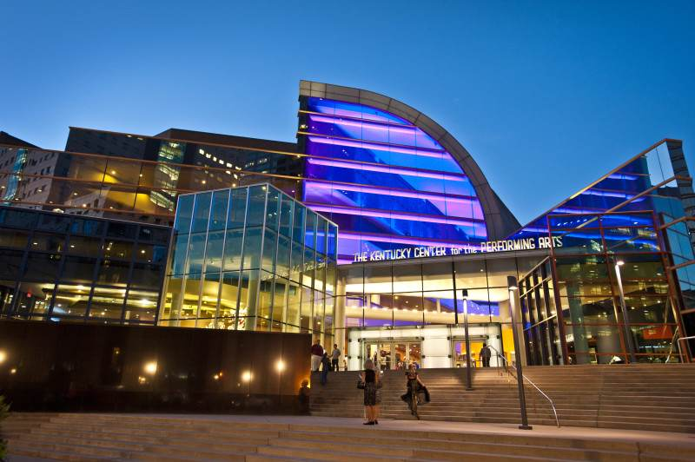

**Kentucky Center for the Performing Arts**

**Dan’s Convention Schedule**

Greetings to Everyone!!! Plans are now finalized for our 2024 Annual Business Meeting and Convention which will be held from October 6-9, 2024, in Louisville, Kentucky. If you haven’t yet made your reservations for the hotel, it is now time to do that, plus complete your convention registration form and submit it to Gerard Dupczak. As explained in the Spring Newsletter and in the e-blast that was recently sent to members, arrangements were made with the Embassy Suites by Hilton to host our annual convention at the Embassy Suites located in downtown Louisville. We were able to negotiate a block reservation for our members at a really good rate of $169.00 per night plus tax, for a total of approximately $198.85 per night. Instructions and contact information for the hotel are listed at the top of the official AFSA registration form that is also included in this newsletter. And remember...every room at the Embassy Suites is a two-room “suite”, plus the rate includes their complimentary cooked-to-order breakfast and their complimentary Manager’s Evening Reception for various liquid refreshments. Our contract also allows our members to use the block rate for up to three days before and three days after our official convention dates of October 6-9, 2024. The Embassy Suites is conveniently located near many sights, including Louisville’s Fourth Street Live, and several museums, such as the Frazier Kentucky History Museum, the Muhammad Ali Center, and the Louisville Slugger Museum. Louisville is also the official starting point of the Kentucky Bourbon Trail and is the home of the booming “bourbon scene” with its Whiskey Row and its Bourbon District that has 12 Bourbon Distillery Experiences within a few blocks of the hotel.

Of most importance right now is for you to make your reservations soon in order to be able to secure a room at our block rate. To do so, you need to call the Hilton national reservations line at 800-774-1500 and reserve your room. Give the reservationist the group code “906” and tell them it is under the name AFSA-IRS. By calling this number, you will be able to secure the $169 rate for up to three days prior and three days after our core nights. You will also be able to request an ADA room. If you have any issues with the national reservation line when requesting nights before or after our core nights, then simply make your reservation for the core nights of October 6th-9th and get the confirmation number that will be sent to your email address. Then call the Embassy Suites in Louisville at 502-813-3800 and ask to speak to the front desk. They should be able to correct the matter and/or add any of the other nights that you desire. You can also feel free to call me at 859-466-7677 or email me at [djpieschel@gmail.com](mailto:djpieschel@gmail.com) and I can resolve the matter.

Finally, please complete your registration form and send your payment to Treasurer Gerard Dupczak no later than Wednesday, August 28, 2024. Doing so, allows us to fulfil commitments that were made to the hotel, and to purchase the required tickets from the various sites we will visit. As noted in the below descriptions, there is limited seating on the chartered buses and limited admission tickets for some of the events. Reservations will be processed on a first-come-first served basis. All requests processed after our limit has been reached will be placed on a waiting list in the order they were received. All advance funds that were paid for activities that cannot be fulfilled due to space not being available, will be refunded to the member.

The following is a tentative day-by-day timetable for what we have planned for this year’s convention. Note that this timetable, like the rest of life as we know it today, is also subject to some changes and modifications.

**Saturday, October 5, 2024**

**Pre-Convention Activities:** With the flexibility of being able to check-in at the Embassy Suites up to three days early, we believe that many of you will choose to travel at the end of the prior week, or on the weekend itself, when it might be more convenient for your schedule. If arriving on Saturday, you will be able to register early in our hospitality room and then select from the many options that will be listed on your handout of On-Your-Own-Activities. We have also arranged to take a “Moonlight Riverboat Cruise” on The Belle of Louisville. Boarding begins at 7:00pm and the cruise runs from 8:00pm -10:00pm at a cost of $40.00 per person. There will be live music, plus a full bar and concessions will be available. The river is about a five-block walk from the hotel, but parking is available in the lot that is adjacent to the riverboat at a current parking rate of $6.25.

One more consideration…traveling on the day before the start of our convention allows you to be first in line for the complimentary cooked-to-order breakfast on Sunday morning (when others are still driving or just arriving, unloading, and preparing for the afternoon activities).

**Sunday, October 6, 2024**

**Registration:** Sunday will be the official start of the convention and will be the day of arrival for most. You will have the option of driving or flying into Louisville International Airport, which is a very easy six mile drive to the hotel. If you don’t plan on renting a car, the Embassy Suites has a complimentary shuttle that can pick you up at the airport. We have also negotiated a special $20 self-parking rate at the parking garage next to the hotel, or you can valet park at the hotel for $40 per night. There are two events scheduled for Sunday.

**In the Afternoon -** The first event will be an afternoon (tentatively set for 3:00pm) private trolley tour of the city at a cost of $30 per person. The tour will take you downtown and to the waterfront, America’s Largest Victorian Neighborhood, Churchill Downs (home of the Kentucky Derby), Museum Row, Whiskey Row, and the new trendy NULU district.

**In the Evening** - The second event will be our annual President’s Meet and Greet from 6:00pm to 8:00pm where everyone will be able to gather and see some old friends and meet some new ones. This year’s Meet and Greet will be held in close proximity to the Manager’s Evening Reception. There will be several food selections which will offer a variety of items, so be sure to come hungry! To top the night off, we will, of course, have our hospitality room open where conversations and nightcaps will be plentiful (as they will be every night).

**Monday, October 7, 2024**

**A Ride on the Kentucky Bourbon Trail –** Not the entire trail, but you will at least start your day at the Frazier Kentucky History Museum which houses The Kentucky Bourbon Welcome Center, the official starting point of the Kentucky Bourbon Trail. Admission will include a 30-minute guided tour of the Spirit of Kentucky Bourbon Exhibit, where you will learn nearly everything you will want to know about bourbon. But that’s not the only attraction in the museum, as it has several other exhibits, plus a permanent collection that features a wide array of historically significant artifacts. Rare and noteworthy objects include Teddy Roosevelt’s “Big Stick”, Geronimo’s bow and arrows, a surplus grave marker from the Battle of the Little Big Horn, a first edition copy of Uncle Tom’s Cabin, and the arrest warrant issued for Mary Todd Lincoln. After leaving the museum, you will be transported to the Angel’s Envy Distillery for a 30-minute tour of the distillery and a 30-minute tasting in their tasting room. Your tour will start at 10:00am and you will be returned to the hotel by about 2:30pm. The $70 per person cost includes your bus ride (including the tip) to both stops, and all admission charges for the tours and the tasting.

**On-Your-Own Activities** – If you choose not to take the above tour, you will find that there are many, many sights to see on your own. A multi-page handout will be provided upon your arrival. Louisville is famous for its Museum Row, which includes the Frazier Kentucky History Museum, the Kentucky Museum of Art and Craft, the Muhammad Ali Center, the Kentucky Science Center, the Louisville Slugger Museum and Factory, and even the Sons of the American Revolution Genealogical Library. There is also the popular “Bourbon District”, a walkable urban experience for anyone looking for a taste of Kentucky. In the bourbon district, you are never more than 5 minutes away from the next attraction. Yellow pole banners and directional signage near every corner navigate you to the next attraction. Included is “Whiskey Row”, aone-block long entertainment district that houses various restaurants, bars, an urban distillery, shops, and other attractions. Other nearby sights will also be included in your handout

.

**Board of Directors Meeting –** Officers and Board Members…Note: Don’t forget to mark your calendars for the annual afternoon Board Meeting that must be attended by all Officers and Board Members. This year’s meeting is scheduled to be held from 3:30pm to 5:30pm.

**Dinner on Your Own –** This is a good evening to have dinner on your own. According to hotel information, there are over 30 restaurants within a four block radius. More specific information will be provided in your handout.

**Tuesday, October 8, 2024**

**“This is Racehorse Country” Tour –** Prepare yourself for a leisurely day in some of the most beautiful farmland in Kentucky…Horse Farmland, that is!!! We start our day in what is known as “The Bluegrass State” with a ride to Paris, Kentucky and a morning visit to the very famous Claiborne Farm. This is one of the most iconic Thoroughbred breeding farms in Kentucky, and the farm where six of the 13 Triple Crown winners were bred. On the tour, we will see some broodmares and foals, and the farm’s current stallions. We will visit the breeding shed and learn about the process, and visit the gravesite of Secretariat, the legendary racehorse who won the 1973 Triple Crown. Our second stop of the day will be in Versailles, Kentucky to a 110 acre estate where we will tour the Kentucky Castle, a very unique property with a storied history. Originally constructed in the late 1960s as a private home, its construction was interrupted several times, halted for a while, then abandoned for nearly 30 years, before being renovated. A Bed and Breakfast was added, but then it underwent a major fire in 2004. New ownership in 2017 has now revitalized it and vast improvements have raised interest in it once again. We will receive a tour and be given the history, and then we will enjoy a very nice lunch that will be created by their chef for our group. After lunch, we travel back to Louisville for our third tour of the day, a visit to the world-famous Churchill Downs Racetrack and The Kentucky Derby Museum. We will be able to walk through the grandstands where the Kentucky Derby happens every year on the first Saturday in May. Our 30-minute guided tour will also take us to the track and a newly opened stable exhibit. Inside the museum, we will see two floors of interactive exhibits. The $150 per person cost for this full day trip includes your bus ride (and tip), lunch, and admission to all three locations. We will start at 8:15am and be back at the hotel a little after 5:00pm, just in time to enjoy the Manager’s Evening Reception.

**Wednesday, October 9, 2024**

**Morning Activities -** As in past years, our annual meeting will be held this year on Wednesday and will begin with an invocation, an opening ceremony, and a presentation by the Color Guard at about 9:00am. Arrangements will still need to be made for our speakers, but we will, of course, invite Guy Ficco, the new Chief of CI, to attend and have him provide his annual update on what’s happening within the organization. That will be followed by our annual business meeting and election of officers. Lunch will be on your own.

**Afternoon Activity –** At this point, the afternoon will befree time and good for any on-your-own activities that you still wish to do.

**The Annual Banquet Dinner –** Our annual dinner is being finalized and will be held in one of the ballrooms at the hotel.

**Thursday, October 10, 2024**

Just as we have the ability to come in three days early, the Embassy Suites is allowing us to stay for up to three days after the convention ends. There’s no need to rush away on Thursday morning. If you have the time and want to see some more of the city on your own, we will have plenty of suggestions for you. Otherwise, this is your check-out day. Safe travels and see you next year.

Dan Pieschel, Event Chair

|  |  |  |  |  |  |  |  |  |  |  |  |  |  |  |  |  |  |  |  |  |  |  |  |  |  |  |  |  |  |
| --- | --- | --- | --- | --- | --- | --- | --- | --- | --- | --- | --- | --- | --- | --- | --- | --- | --- | --- | --- | --- | --- | --- | --- | --- | --- | --- | --- | --- | --- |
| 2024 AFSA-IRS ANNUAL CONVENTION REGISTRATION | | | | | | | | | | | | | | | | | | | | | | | | | | | | | |
| **Embassy Suites Hotel – October 6-9, 2024** | | | | | | | | | | | | | | | | | | | | | | | | | | | | | |
| 501 South Fourth Street, Louisville, KY 40202 | | | | | | | | | | | | | | | | | | | | | | | | | | | | | |
|  | | | | | | | | | | | | | | | | | | | | | | | | | | | | | |
| **To make your hotel reservation:** | | | | | | | | | | | | | | | | | | | | | | | | | | | | | |
| Call 800-774-1500 | | | | | | | | | | | | | | | | | | | | | | | | | | | | | |
| **Use Group Code 906 to identify as being with the AFSA Convention** | | | | | | | | | | | | | | | | | | | | | | | | | | | | | |
| **Registration Deadline is August 28, 2024** | | | | | | | | | | | | | | | | | | | | | | | | | | | | | |
|  | | | | | | | | | | | | | | | | | | | | | | | | | | | | | |
| **AFSA Member:** | | | | First: | | |  | | | | | | | | | | | | | | Last: | |  | | | | | | |
| **Guest:** | | | | First: | | |  | | | | | | | | | | | | | | Last: | |  | | | | | | |
| (This will be the name that will be on your convention name badge.) | | | | | | | | | | | | | | | | | | | | | | | | | | | | | |
| Address: | | |  | | | | | | | | | | | | | | | | | | | Phone: | | | |  | | | |
| City: | | |  | | | | | | ST: |  | ZIP: | |  | | | | | | | | | Cell: | | | |  | | | |
| E-Mail: | | |  | | | | | | | | Arrival date: | | | | | | | |  | | | | | Departure date: | | | | |  |
| **Registration** | | | | | | | | | | | | | | | | | **Fees (per person)** | | | | | | | | | | **#** | | **Amount** |
| AFSA Member Registration Fee | | | | | | | | | | | | | | | | | $225 | | | | | | | | | |  | | $ |
| Guest Registration Fee | | | | | | | | | | | | | | | | | $225 | | | | | | | | | |  | | $ |
| Hospitality Room Non-Alcoholic Drink Preference Discount | | | | | | | | | | | | | | | | | -$10 | | | | | | | | | |  | | $ |
| **Registration fees include:** Sunday Evening President’s Meet & Greet; Opening Ceremony; Wednesday Evening Banquet Dinner; all Hospitality Room Sessions. | | | | | | | | | | | | | | | | | | | | | | | | | | | | | |
|  | | | | | | | | | | | | | | | | | | | | | | | | | | | | | |
| # |  | Attending Sun. Evening President’s Meet & Greet  **(Included in Registration Fee)** | | | | | | | | | | | | | # | | |  | | | Attending Wednesday Evening Banquet  **(Included in Registration Fee)** | | | | | | | | |
|  | | | | | | | | | | | | | | | | | | | | | | | | | | | | | |
| # |  | Attending Wed. AM Business Mtg. | | | # |  | |  | | | | | | # | |  | | | |  | | | | | | | | | |
| **Please indicate the activities you wish to participate in:**  **(See convention schedule for activity details)** | | | | | | | | | | | | | | | | | | | | | | | | | **Fees**  **(per person)** | | | **#** | **Amount** |
| Sat. Oct. 5 Belle of Louisville Moonlight Riverboat Cruise (evening) | | | | | | | | | | | | | | | | | | | | | | | | | $40 | | |  | $ |
| Sun. Oct. 6 Private Trolley Tour of the City (afternoon) | | | | | | | | | | | | | | | | | | | | | | | | | $30 | | |  | $ |
| Mon. Oct. 7 A Ride on the Kentucky Bourbon Trail (half-day Bus Trip) | | | | | | | | | | | | | | | | | | | | | | | | | $70 | | |  | $ |
| Tue. Oct. 8 This is Racehorse Country (full-day Bus Trip) | | | | | | | | | | | | | | | | | | | | | | | | | $150 | | |  | $ |
|  | | | | | | | | | | | | | | | | | | | | | | | | |  | | |  |  |
|  | | | | | | | | | | | |  | | | | | | | | | | | | |  | | |  |  |
|  | | | | | | | | | | | | | | | | | | | | | | | | |  | | |  |  |
| **Make your check payable to AFSA** | | | | | | | | | | | | | | | **Total Amount Paid:** | | | | | | | | | | | | | | **$** |
|  | | | | | | | | | | | | | | | | | | | | | | | | | | | | | |
|  | | | | | | | | | | | | | | | | | | | | | | | | | | | | | |
| **E-mail registration form to gdupczak@att.net and mail your check to:** | | | | | | | AFSA-IRS  P.O. Box 108  Schererville, IN 46375 | | | | | | | | For general CONVENTION INFO, please visit www.afsa-irs.org | | | | | | | | | | | | | | |

**REGISTRATION DEADLINE IS AUGUST 28, 2024**

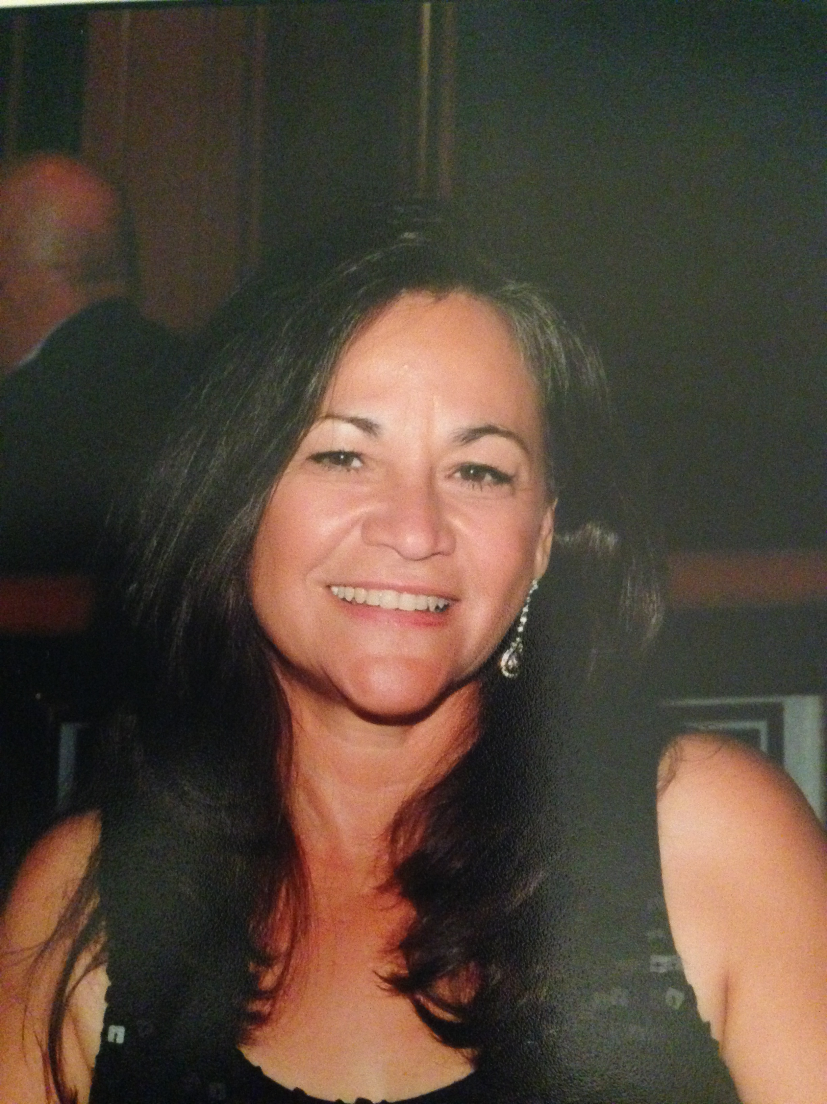**Executive Director’s Corner – Summer 2024**



Greetings and salutation from Helotes, Texas!!!

***AFSA-IRS Convention***

***October 8 – 11, 2023***

**Dan Pieschel, and the Convention Planning team have been working hard. They are finalizing the details and putting together an amazing package of activates and tours for the convention. I have my hotel reservations and booked my flight. I am looking forward to the camaraderie, with old friends and meeting new friends.**

**Every year the Scholarship Committee has a very tough task. The pool of applicants continues to be outstanding. Thank you to all of you who donate to the scholarship fund to the AFSA-IRS Memorial Scholarship fund and to William Schroeder, President of Madison Associates, Inc. for his very generous donation to the James F. Howe, Sr and Frank Fotinatos Scholarship Fund.**

I am looking forward to seeing you at:

**2024 AFSA Convention**

**Louisville, KY**

**October 6-9, 2024**

**Have a marvelous day!**

**Adieu,**

**~ *Mary* ~**

**A MESSAGE FROM CHIEF GUY FICCO**

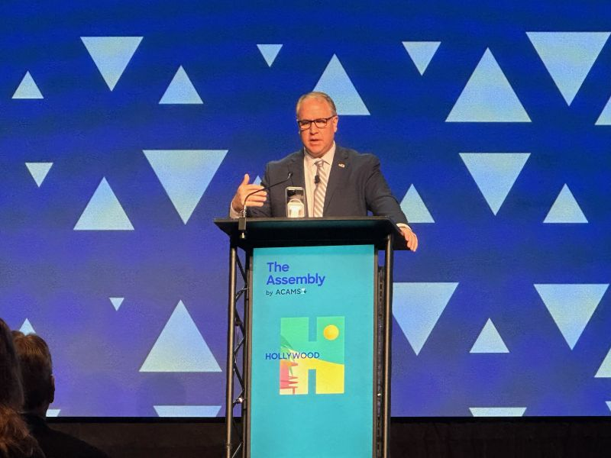

**Message from Chief Guy Ficco**

**August 2024**

Hello CI Family. If you’re following me on LinkedIn, a little while back I posted a short [message](https://www.linkedin.com/feed/update/urn:li:activity:7222322812361883648/) about the 105th anniversary of CI. I’d like to zoom in a bit on some of the ideas I discussed there. In the few short months that I’ve served as Chief, I’ve been incredibly impressed by the work of our talented team of special agents and professional staff. Since we’re wrapping up CPE season, I’ve been very fortunate to visit several field offices and have gotten to see some of this work firsthand.

It’s amazing to think that for over a century, CI has been at the center of tax crime enforcement in the United States. And while we are, without a doubt, global leaders in investigating crimes that touch the financial realm (which nearly every crime does), I’m excited that our current combination of assets and expertise ensures that we are future- proofing our agency against ever-evolving global threats.

From our earliest days, CI has been the only agency with the authority to investigate criminal income tax violations under the Internal Revenue Code. These unique authorities have allowed us to develop investigative capabilities that ensure we either lead or have a prominent seat at the table in tackling some of the most complex and high-profile federal investigations.

But while our early efforts focused almost exclusively on combating tax crimes, our investigative aperture has expanded quite a bit to include a wider variety of criminal activity, touching now on digital currency, human trafficking, fentanyl-related cases, terrorism and cybercrimes. This expansion demonstrates the increasing complexity of crimes with a financial-nexus, and the mandate for a specialized, highly adaptable workforce, which I am proud to say we have.

One of the most impressive aspects of CI's evolution is our ability to leverage technology in a rapidly changing financial world. However, as you can all attest to, technology alone is not the key to our success. Our real strength is in our people—dedicated special agents and professional staff, who bring a wealth of experience, expertise, and a commitment to excellence.

As the Chief of CI, I take enormous pride in the quality and diversity of our workforce. This diversity is not just about demographics. It’s about the richness of thought, experience, and varied backgrounds that our agents and professional staff bring to the table. These perspectives are vital to our effectiveness and ability to continue to innovate on the job.

So, as we celebrate 105 incredible years of service, the next century looks even brighter! I am thrilled to lead a team that represents the most talented and capable version of CI in our history. And I can say without question, our commitment to excellence, innovation, and diversity positions us to confront and overcome future challenges for decades to come.

AFSA COLLEGE SCHOLARSHIPS

LITEPURP.gif (5531
 bytes)

# 

**James P. Howe Sr. and Frank Fotinatos Scholarship-** These scholarships are for $3,000 and are for students seeking law enforcement careers and are administered by AFSA on behalf of its primary benefactor, William R. Schroeder, President of Madison Associates, Inc., in memory and honor of James F. Howe, Sr. and Frank Fotinatos, former IRS CI agents who worked for Madison. The recipients of this award are:

Esteban Sanchez

Mason Barnett

Their Bios follow:

**Esteban Sanchez.** Hello, my name is Esteban(EJ) Sanchez. I am a rising freshman attending the University of Dayton. I have recently graduated from Sacred Heart Griffin(SHG) high school in Springfield, IL. While attending SHG I participated in several extracurricular and volunteer activities. I was a member of both the cross country and track teams, acting as a captain for both by my senior year. I completed hundreds of service hours during my four years at SHG, completing over 100 hours in my senior year alone. I have also received several academic rewards and recognitions during my time at SHG. I was a member of both the National Honors Society and National Spanish Honors Society. I was also awarded National Hispanic Recognition from the College Board for notable PSAT scoring.

As I begin college, I am planning to major in computer science with a focus on cyber security. Through this degree I am hoping to develop the necessary skills to become proficient in defending digital information from cyber attacks, whether in the public or private sector. This is particularly applicable to me while studying at the University of Dayton as UD has an agreement with the National Security Agency(NSA) that allows me to receive an additional certification in cyber security from the NSA through my coursework. I hope to achieve all of this in an effort to serve either my community, my state, or even my nation by protecting it from cyber threats in a time when the damage one could cause continues to grow exponentially. My grandfather, Bernie Coleman served the IRS as a special agent for many years in the central Illinois region. I hope to continue to serve my community as he and other special agents that represent this scholarship have.

**Mason Barnett.** My name is Mason Barnett and I am from Kingsport, Tennessee. I graduated from Dobyns-Bennett High School in May 2024 and I will be attending the University of Tennessee in Knoxville, where I will be majoring in Accounting and Finance. After graduating college I plan to pursue a career in law enforcement. While in high school I participated in several extracurricular activities including: a 4-year member of the varsity baseball team, BETA, and FBLA Clubs, National Honor Society, and I am a Tennessee/Virginia Scholar. I also served as a student representative on the Career and Technical Education (CTE) Advisory Committee at DBHS and as a leader in my local Mayor's Youth Council, all while graduating with a 4.3 GPA. I am extremely honored to have been selected as a recipient of the James F. Howe, Sr. & Frank Fontinatos Scholarship.

The Nominating Committee has chosen the following recipients for the General Scholarship and will be receiving a scholarship of $2000 each.

Tyler Kuehn

Madelyn Kost

Thomas Avery

Daniel Vilhard

Hailee Kindred

Matthew Holenstein

Their Bios follow:

**Tyler (TJ) Kuehn** is a dedicated and ambitious student who will be attending Purdue University in the fall to pursue Pre-Medicine. He graduated with an impressive 3.9 GPA from Vista Ridge High School in Cedar Park, Texas, where he was actively involved in various extracurricular activities. TJ's father, Michael Kuehn, is a retired IRS-Special Agent from the Phoenix Field Office, who has instilled in him a strong sense of discipline and work ethic. TJ is also an avid volunteer in his community including multiple years as a Food Bank volunteer and was co-leader of the State Champion Improv Comedy Group for Texas. He has also showcased his acting skills in multiple lead roles in theatre musicals and plays. In addition to his academic and extracurricular achievements, TJ has also worked at a local pizza parlor and as a camp counselor for the YMCA camp in Lakewood, Wisconsin. He is grateful for the scholarship he received from the AFSA-IRS, which will help him to pursue his higher education goals. With his passion for medicine and his commitment to making a positive impact in his community, TJ is well on his way to achieving great things in the future.

**Madelyn Kost.** Hi, my name is Maddy Kost. I am a 2024 graduate of Buckeye High School in Medina, Ohio. I plan to major in Health Sciences at the University of  Toledo before going to graduate school to become a physician assistant. I hope to graduate with honors from college, gain valuable experience relating to my future career, and continue to be involved in school activities while helping the community. After graduation, I plan to use the skills I have learned to make an impact in the healthcare industry. I intend to use this degree to find my calling in life. Making an impact in the medical world and helping people improve their daily lives is important to me. I want people to trust me, feel welcome and know it’s okay to accept help and support. I am so excited to begin this new chapter. I am looking forward to wherever it takes me.

Throughout high school, I maintained a 4.76 GPA. I competed in three varsity sports: cross-country, basketball and track. I was captain of my basketball and cross country teams and a student council class officer. I was also involved in freshman mentors, National Honor Society, tutoring and athletic training. I am extremely honored to be selected for the Memorial Scholarship. I would like to thank AFSA-IRS, as well as its members and donors for their support in my academic pursuits.

**Thomas Avery.** My name is Tommy Avery and I am from Kingwood, Texas. I’m super excited for the opportunity to attend Texas A&M this fall as a member of the Class of 2028. Throughout my four years at Kingwood High School, I was heavily involved with sports. In soccer, I was a member of multiple varsity district-winning teams that made deep runs in the 6A Division State Playoffs. While in track, I was named the team captain and earned my place at number eight on the all-time Kingwood High School Top Ten list with my 200 meter race time. I was also a member of several clubs, holding a leadership position in the National Honor Society as Chapter President. As President, I organized and approved service projects in the local community, most notably an excursion to the Houston Food Bank with 80+ students participating.  I also served in Student Government as a Class Officer, where I helped plan senior events like Prom and Senior Picnic. Outside of school, I earned my Eagle Scout and served in my Catholic Church community as a youth group leader for teens preparing to make their Confirmation. In addition to learning in the classroom, I want to build upon my social and leadership skills at Texas A&M so that I can make an impact in my future workplace by using my knowledge to develop new technology—like an antibiotic or machine—that would better the lives of other people. Activities like volunteering at St. Mary’s in College Station, playing either Club Soccer or other intramural sports, and working with professors and other students in one of the many research labs A&M has to offer will hopefully guide me towards achieving that goal. Again, I express my gratitude for your consideration and investment in my education, and I look forward to my time at Texas A&M.

**Daniel Vilhard.** Thank you to the members of AFSA- for selecting me for this scholarship. My father retired from IRS-CID 2020 after working as a Special Agent in Nashville and St. Louis. I am the oldest of five children. I graduated from Christian Brothers College High School in May. I received academic honors every semester in high school and have completed 18 hours of college credit through AP exams while in high school. I was the Captain of the Scholar Bowl team. I was also on the Cross Country and Track Teams. While in High School I participated in a service project in Appalachia and working with a local organization tutoring the children of refugees from the Afghan war. I earned the rank of Eagle Scout in 2024. I will be attending Missouri University of Science and Technology in then fall and plan to study Chemical Engineering.

**Hailee Kindred.** Hello, my name is Hailee and I grew up in Portland, OR. When

I was fourteen I relocated to Stafford, VA due to my government father getting a new position in the IRS. My whole life I have played numerous sports, but found myself to focus and have a passion for soccer. I played with a travel soccer team as well as the high school varsity team. While athletics is a large portion of my life, I have devoted my time to many other extracurriculars. Moreover, I was very engaged in the Fellowship of Christian Athletes, including being one of the leaders. In the fall, I will be starting college at James Madison University where I plan to enroll in the College of Business to study marketing and minor in entrepreneurship. I one day hope to own a business of my own.

**Matthew Holenstein.** Matthew Holenstein is a 2024 Magna Cum Laude graduate of Independence High School in Thompson's Station, Tennessee.  He is a member of the National Honor Society, volunteered with the school's Best Buddy program, and played on the school lacrosse team.  Matthew graduated with a Seal of Biliteracy diploma in Spanish.  This past summer, he traveled to Costa Rica with the school Spanish program to further his Spanish studies while taking part in mission work at a local school and community center.  Matthew will be attending the University of Tennessee - Knoxville majoring in Business Administration.

**DONATIONS**: Anyone may make donations to the AFSA-IRS for the Scholarship Fund.

Donor Name: ___________________________________________________

Enclosed is my check for $10.00 ____, $50.00 ____, $100.00 ____, or other $____

Send donations to: Gerard Dupczak, 1428 Charlevoix Way Schererville, IN 46375



Terresa Lato Julie Bomstd

Canyon Lake, TX Las Vegas, NV

Shawn Batsch Shari Page

Lakewood, FL Memphis, TN

Ryan Talbot Nolan Fuller

Amesbury, MA Ogdensburg, NY

Randy Krueger Gary Haley

Walnut Creek, CA Fayetteville, AR

Joseph Villa George Peralta

Chicago, IL Round Rock, TX

Gregory Ryan Alexander James Killeen

Fayetteville, AR Brookfield, CT

Daniel Richard Johnson Scott Lanier

Midlothian, VA Oakton, VA

Jeanette Paterson Ross Tory Andre Simmons

Tulsa, OK Pflugerville, TX

Christian S. Daley

Seminole, FL



**There are special people in our lives who never leave us,**

**even after they are gone.**

**In Memoriam**

Dallas L. McKnight

Knoxville, TN

Jerry Price

Owens Crossroads, AL

Larry C. Halper

Midway, UT

**From the Editor** Just, a quick note for your information. I have been editing the AFSA Newsletter three times per year since 2009 when I made my first and only trip to San Diego (what a beautiful city!) The time has come for some fresh ideas and a new editor for the newsletter so we are looking for someone to fill shoes (shouldn’t be difficult), When I first started, it took me about 16 hours over four days to put everything together. Now, this newsletter was completed in half that time. Hardest part being accumulating the content and them placing it within the confines of the newsletter. When finished, I look at it and usually say, OOPS. It, needs more content. The newsletter, for publication, has to have a certain number of pages, always divisible by 4. So, if I have 14 pages, I either have to add two pages of content or leave out two pages of content (which I have never done…I can always find something). Bottom line…we need someone to take over. I’ve agreed to finish out the year, so my LAST newsletter will be the winter edition and if someone doesn’t take over, it will be the last AFSA newsletter. Take care and I’ll see you all in Louisville.

Ross

**AFSA-IRS OFFICERS AND APPOINTED OFFICIALS**

**Officers Appointed**

Iris Bohannon (AR) President Mary Ruiz Executive Director

Beth Putman (MD) V/P President Elect Bob Armentrout Parliamentarian

Ismael Nevarez (AZ) 2nd Vice President A. Jack Fishman Attorney

Gail Donaldson (DE) Secretary Ross Brown Newsletter Editor

Gerard Dupczak (IN) Treasurer Vacant Tech Advisor

Gerard Dupczak (IN) Past President Vacant Historian

Mark Kroczynski Scholarship Chair

**AFSA-IRS REGIONAL DIRECTORS AND REGIONAL REPRESENTATIVES**

**REGION Regional Director Regional Representatives**

1 Phil Hall (MA) Matthew Cola, Babylon, NY

Robert Galbraith, E. Amherst, NY

Charles Franssen, Huntington, NY

2 Robert Schmus (NJ) Alan Fogel, Manalapan, NJ

John Gagliardo, Lincoln Park, NJ

Robert McDugall, Blue Bell, PA

3 Mary Fran Martin (MD) Kathy Montemora, MD

4 Elizabeth Fleaher (OH) Tedd Boomershine, Kettering, OH

5 Cynthia Fish (NC) David W. Jansen, Tulsa, OK

6 Michael Stephens (FL) Angelo Troncoso, Clearwater, FL

Dave Beitzel, Naples, FL

Orlan Smith, Orlando, FL

Robert McLaughlin, Ponce Inlet, FL

Jeff Karsh, Plantation, FL

Larry Sands, Keystone Heights, FL

7 Robert Kuschel (IL) Inar “Smitty” Morics, Des Moines, IA

Ronald Cipolla, Eagan, MN

Tom O’Halloran, St. Louis, MO

8 Calvin Puryear (TX) Ed Martin, Austin, TX

Robert Schweitzer, Sun City West, AZ

Dennis Carey, Glenwood Springs, CO

Mike Mayott, Billings, MT

9 Rich Malone (CA) Alex Seddio, San Francisco, CA

Reginald Norberg, Seattle, WA

**AFSA – IRS Membership Application**

We STRONGLY encourage members to apply on line: [www.afsa-irs.org](http://www.afsa-irs.org), however you may mail completed application with $50 check payable to AFSA for first year dues to: **AFSA-IRS**

**P.O. Box 1187**

**Helotes, TX 78023**

Name: _________________________________________________________________________________________

Home Address: ______________________________________________________________________________________________

City: ______________________ State: ____________ Zip Code: ______________ Telephone: ( ) ________________

Home Email Address: __________________________________________________________________________________

Date of Birth: _________________________________________ Place of Birth: ______________________________________

IRS-CI Special Agent Service Dates: From: ______________; To: ______________ Are you a current Special Agent? _______

Retirement Date: ___________; Spouse’s Name: ___________________________________________________________________

Current or Last Post of Duty: _________________ Current or last Supervisor & Ph #: __________________________________

Current Employment (type of work): _____________________________________________________________________________

Business Name: ______________________________________________________________________________________________

Address: City: ___________________________ State: ______________Zip Code: ____________

Telephone: ( ) ________________________________ FAX: ( ) ___________________________________________

Business Email address: ______________________________ Cell Phone ( ) ____________________

As an AFSA member, I am interested in:

Doing investigative work ____ Yes ____ No Being a member of an AFSA committee ____ Yes ____ No

Serving AFSA in other positions ____ Yes ____ No Being an AFSA Representative ____ Yes ____ No

(Representatives assist Regional Directors)

Place a check mark in the blank for the items that apply to your skills, training, accreditation, or interest:

1. Attorney _____

AFSA receives requests from various sources for members who may be interested in performing different types of work. If you desire to have this type of information available for AFSA to assist in matching your skills, expertise and abilities to a particular request, please complete this part of the membership form.

1. Certified Public Accountant _____
2. Certified Fraud Examiner _____
3. Enrolled Agent _____
4. Foreign languages _____

Specify:

Language(s) _________________________

1. Instructor training experience _____
2. Foreign:

Teaching experience _____

Consulting assignments: _____

1. Computer forensics _____
2. Investigative equipment training experience _____
3. Licensed or certified private investigator _____
4. Management training experience _____
5. Other skills or investigative interest: _____

Specify______________________________________________ Membership is open to all retired, former and current IRS special agents with at least five years IRS special agent service. Current special agents are admitted as non-voting associate members. I am applying (or submitting changes) for membership in the Association of Former Special Agents of the Internal Revenue Service. I am either a retired special agent, a former special agent, or a current special agent. I have neither been convicted of a felony nor left the IRS under any adverse circumstances.

Signed: ________________________________________________ Date ________________________________________

**AFSA REGIONS AND AREAS OF COVERAGE**

|  |  |
| --- | --- |
| **Region** | **Area of Coverage** |
| 1 | Connecticut, Maine, Massachusetts, New Hampshire, New York, Rhode Island, and Vermont |
| 2 | New Jersey and New Jersey |
| 3 | Delaware, District of Columbia, Maryland, Virginia, U.S. Territories and International |
| 4 | Arkansas, Indiana, Kentucky, Michigan, Ohio, Tennessee, and West Virginia |
| 5 | Alabama, Georgia, Louisiana, Mississippi, Oklahoma, North Carolina and South Carolina, |
| 6 | Florida |
| 7 | Illinois, Iowa, Kansas, Minnesota, Missouri, Nebraska, North Dakota, South Dakota, and Wisconsin |
| 8 | Arizona, Colorado, Montana, Nevada,New Mexico, Texas, Utah, and Wyoming |
| 9 | Alaska, California, Hawaii, Idaho, Oregon, and Washington |

**ASSOCIATION OF FORMER SPECIAL AGENTS**

**OF THE INTERNAL REVENUE SERVICE (AFSA)**

**P.O. Box 1187**

**Helotes, TX 78023**

**992 AFSA members as of May 1, 2024. Help recruit new members for AFSA**